- Querying Own Data (text file) with no OpenAI Integration

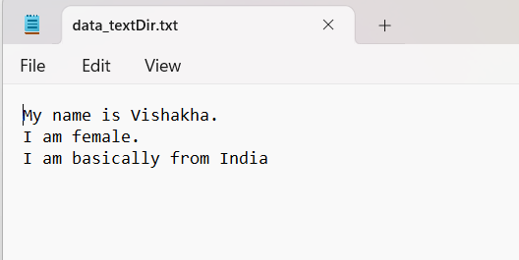

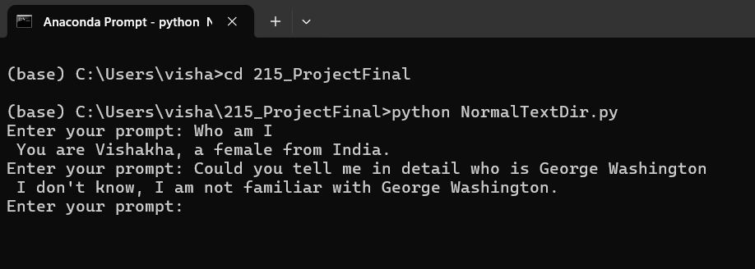

- Querying Own Data (text file) with OpenAI Integration

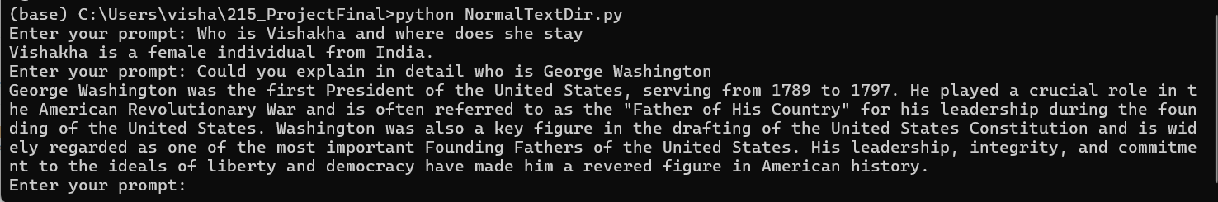

- Querying Own Data(folder) with no OpenAI Integration

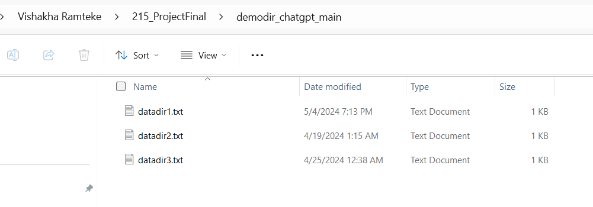

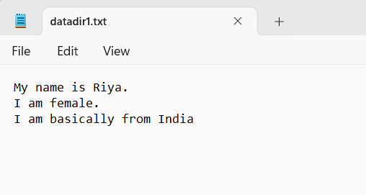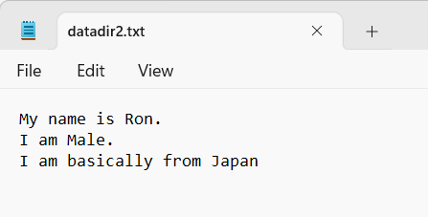

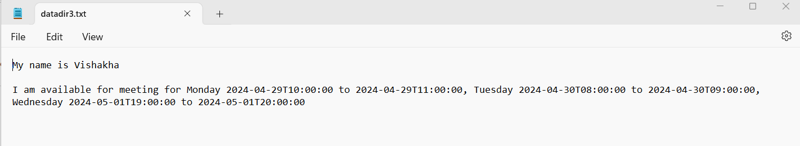

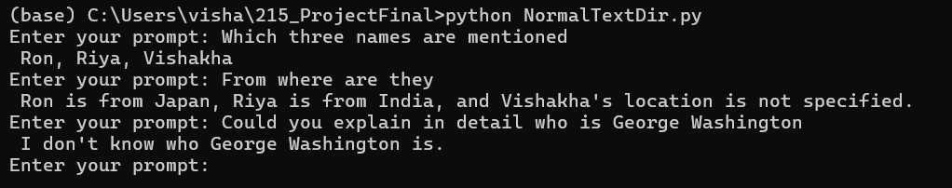

- Querying Own Data(folder) with OpenAI Integration

